High level Architecture
Version 3

P13: ContinuumAi

Student ID | Name
26100059 | Ali Faizan Chughtai
26100146 | Muhammad Bazaf Shakeel
26100063 | Umer Raja
26100038 | Mustufa
26100029 | Muhammad Nafees

Table of Contents

1. Introduction 3
2. Non-functional requirements/Quality attributes of the system 4
3. Security Requirements 5
4. Project Risk Management 6
4.1 Potential Project Risks and Mitigation Strategies 6
5. System Architecture 7
5.1 Architecture Diagram 7
5.2 Architecture Description 8
5.3 Justification of the Architecture 9
6. Tools and Technologies 13
7. Hardware Requirements 14
8. Development Environment Preparation 15
9. Deployment Platform 15
10. Use of Generative AI 16
11. Who Did What? 17
12. Review checklist 17

Introduction
Project Overview: ContinuumAI is an Agentic AI system designed to function as a personal data scientist for non-technical users in business roles. Its primary objective is to enable decision-makers - such as managers in HR, Sales, Marketing, and Product teams - to access and act upon data insights through natural language prompts, without requiring coding or technical expertise.
The system bridges the gap between data science capabilities and business needs by automating the full analytics workflow: from data ingestion to descriptive, diagnostic, predictive, and prescriptive analysis. It provides outputs such as trends, visualizations (e.g., bar charts, line graphs), forecasts, performance metrics, and actionable recommendations entirely based on user queries in plain English.
For example, a regional sales manager might want to understand what factors influenced last quarter’s revenue dip or forecast next month's performance. Instead of relying on a data team, they can simply ask the system in natural language. ContinuumAI automatically identifies the relevant data, applies the right analytical methods, and delivers clear, actionable insights empowering the user to make informed decisions instantly.
While the long-term goal is to support all major business domains, the current version of ContinuumAI is focused specifically on the Sales domain, allowing us to build deep and meaningful capabilities before expanding further. (Hence, for this document as well we will be focussing on sales only)
As for the data required to support our sales-oriented features, we are currently in discussions with firms to obtain sales related datasets, once a functional MVP has been achieved. For initial development, we will explore open-source alternatives (e.g., Kaggle, Hugging Face) to develop an idea of standard dataset forms and generate synthetic data based on well-defined schemas informed by the open-set datasets as well as input from industry advisors, in light of the use cases detailed in the previous document.

Non-functional requirements/Quality attributes of the system

Sr# | Requirements
1 | The system will process and display visualizations for 90% of natural language queries on datasets under 500 MB within 10 seconds.
2 | A 100 MB CSV file will be ingested, processed, and made ready for analysis in under 60 seconds.
3 | After a 15-minute tutorial, new users must achieve an 80% first-attempt success rate when generating a sales trend visualization without assistance.
4 | The system must support 20 concurrent users with no more than a 20% degradation in average query response time compared to a single user.
5 | Exporting any chart to a PNG file or data table to a CSV file must complete within 5 seconds.

Security Requirements

Sr# | Security Risks | Potential Losses | Controls
1 | Broken Access Control | Confidential data exposure, Data integrity compromise,  Legal and compliance issues | Session Isolation,  Access Control Validation,  Token Management
2 | Cryptographic Failures | Confidential Data Exposure,  Data Integrity Compromise,  Regulatory Penalties | Encrypt Data at Rest and Transit,  Password Hashing,  Key Management
3 | Injection | Confidential data exposure, Data integrity compromise,  System Compromise | Input Validation and Sanitisation,  Parameterized Queries for SQL
4 | Unrestricted Resource Consumption | Denial of Service (DoS), Increased Operational Costs | Rate Limiting,  Resource Quotas (for network bandwidth etc.)
5 | Server Side Request Forgery (SSRF) | Data Exposure,  Denial of Service (DoS) | Input Validation and Sanitization,  Allowlists for URL Origins

Project Risk Management

Potential Project Risks and Mitigation Strategies

Sr. | Risk Description | Mitigation Strategy
 | Staff turnover  Experienced staff leaves the project before it is finished. | If an experienced team member leaves, detailed documentation and regular knowledge-sharing sessions (which we will maintain on a weekly basis) will ensure continuity. These practices will prevent dependency on any single person, allowing new or existing members to seamlessly assume responsibilities using the maintained records and notes.
 | Requirements change  Changes in requirements that require major design rework are proposed. | If major requirement changes are proposed, they will go through a formal change management process to assess their impact and gain team approval. Once evaluated, the changes will be integrated incrementally through the accepted plan. This won't be a major risk since we will be using an agile workflow, where new requirements can also be accommodated in later stages by creating dedicated sprint plans for their implementation.
 | Underestimation  The size of the system is underestimated. | If the system turns out larger than estimated, the team will refine effort, budget and timeline estimates iteratively and consult experienced advisors to reassess scope and provide guidance on necessary adjustments. Those adjustments will then be incorporated into the plan to make up for this risk.
 | Technology change  The underlying technology on which the system is built is superseded by a new technology. | If the chosen technology is superseded, the team will actively monitor emerging alternatives and, if a superior option is identified, trigger a contingency plan to evaluate the costs, benefits, and timing of migration to ensure minimal disruption.
 | Code generation  The code generated by generative AI is inefficient. | If AI-generated code proves inefficient, developers will review and refactor critical sections, and where inefficiencies are systemic, replace underperforming components with human-developed modules to ensure performance standards are met.
 | Data  Required data is not available. The required data may be for training of ML Model or for some other purpose. | If required data is not available, synthetic datasets will be generated based on our universal schema provided in the previous document. It will be ensured that the data generated via the universal schema mimics real world scenarios.
 | Stakeholder management  Customers fail to understand the impact of requirements change. | If customers fail to understand the impact of requirements change, the team will clearly communicate cost, time, and design implications and conduct workshops or demos to illustrate the real-world effects before proceeding.
 | Off-the-shelf components and libraries  Software components/libraries that were planned to be used do not contain desired features or contain defects, i.e., they cannot be used as planned. | If planned components or libraries lack desired features or contain defects, equivalent alternatives will be evaluated, and if none are viable, stable fallback versions will be used while a longer-term solution is developed.

System Architecture

Architecture Diagram

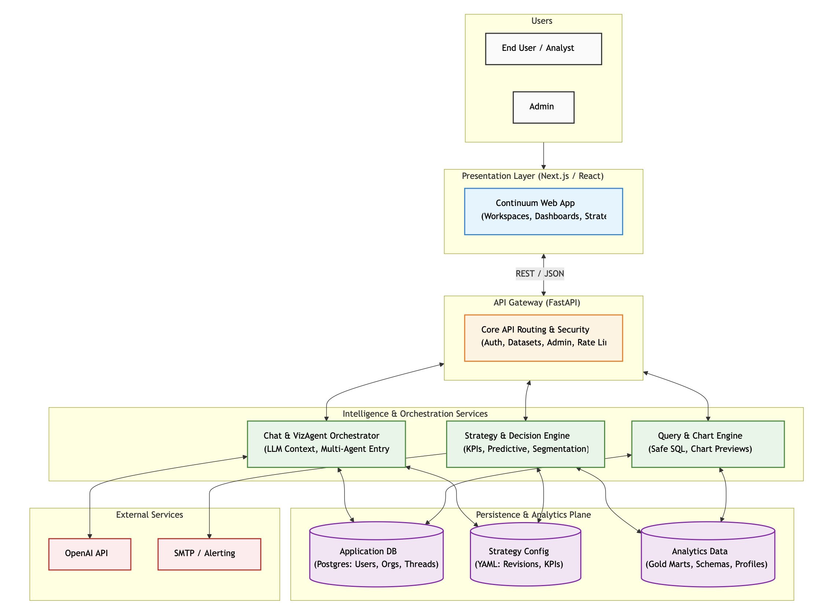
Revised Edition for Sprint-4 Final.

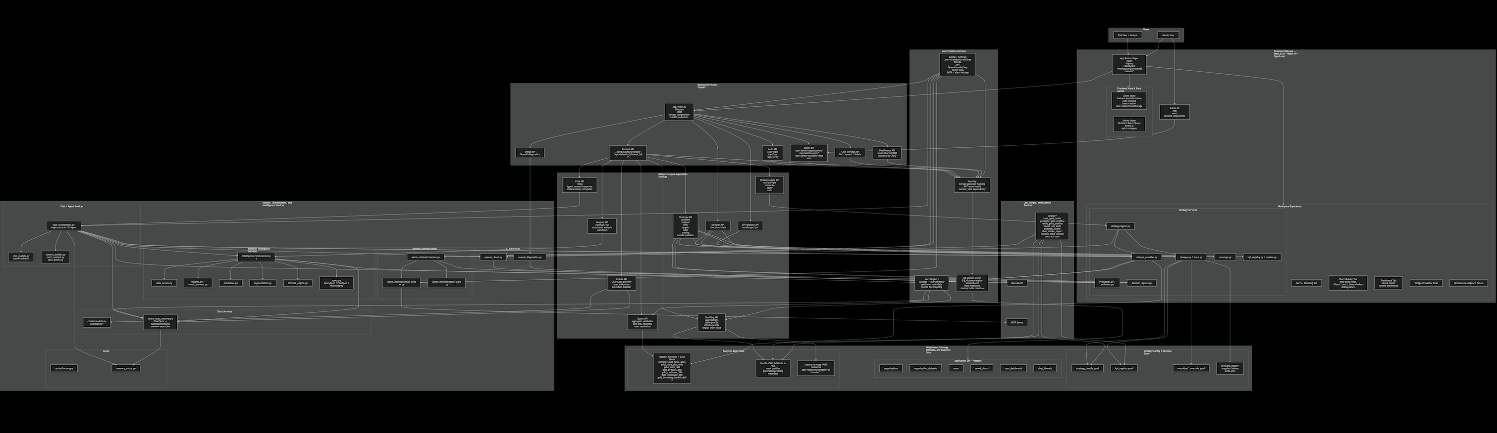
A more detailed look into the architecture. Due to readability issues, a separate PNG for the architecture has been uploaded aswell.

5.2 Architecture Description

Subsystem Descriptions
1. Frontend User Experience Layer (Next.js & React)
The presentation layer is a modern, responsive web application built on Next.js 16, React 19, and TypeScript. It utilizes the App Router and manages state via a hybrid approach: Zustand for persisted client state (auth, ui-context) and TanStack React Query for server state caching. The core analytical experience is divided into dynamic Workspace tabs:
- Marts / Profiling Tab: Renders dataset-level insights, column metadata, and data quality indicators.
- Chart Builder Tab: A guided visualization tool utilizing drag-and-drop fields. It restricts operations based on column profiles (e.g., prevents aggregating IDs) and supports filters, sorts, and time windows.
- Dashboard Tab: Persists user-created charts and named dashboards for ongoing monitoring.
- Strategy Tab: A specialized view for KPI libraries, targets, reconciliation, evaluation, and advanced YAML-based rule editing.
- VizAgent & Decision Panels: The conversational AI sidebar and embedded Decision Intelligence panels that contextualize the data on the screen.

2. API Gateway Layer (FastAPI)
Acting as the secure front door to the backend, this layer is built on FastAPI. It handles CORS, lifespan events, and centralized router composition.
- It exposes distinct, domain-separated routers: Auth (/api/login, /api/me), Admin (user/org management), Datasets(available marts), Chat Threads (history management), and Dashboards.
- This layer ensures that all client requests are authenticated and strictly routed before hitting any heavy orchestration or database logic.

3. Dataset-Scoped Application Services
This layer transforms raw API requests into domain-specific actions, scoped strictly to the dataset the user is currently analyzing.
- Profiling API: Handles aggregations and serves table/column profiles.
- Query & Charts API: Assembles safe SQL, validates aggregate requests, previews ChartSpecs, and resolves mart logic.
- Chat API: The typed request/response entry point for conversational analytics.
- Strategy & Decision APIs: Manages KPI extractions, bundles, decision states, and applies strategy rules.

4. Core Platform Services
The foundational backend utilities that support the entire application infrastructure.
- Security & DB Sessions: Manages bcrypt password hashing, JWT issuance/verification, and establishes the SQLAlchemy engine and SessionLocal for database interactions.
- Config Management: Centralized environment variable handling via pydantic-settings (DB URLs, OpenAI keys, SMTP configs).
- Mart Registry: The critical mapping engine that connects logical datasets to physical "Gold" marts and their corresponding profile file mappings.

- Domain, Orchestration, and Intelligence Services
Formerly a bolt-on feature, the AI and intelligence engine is now the central nervous system of the application, utilizing OpenAI to power both conversational and analytical workflows.
- Chat / Agent Services (VizAgent): Orchestrates the LLM context by combining mart metadata (mart_context.py) and user intent to generate chart specifications (spec_patch.py).
- Chart Services: Resolves ChartSpecV1 models into actionable query aggregate requests.
- Decision Intelligence Services: Executes advanced analytical workflows including data insights, predictive modeling, segmentation, and a dedicated formula engine.
- Strategy Services: Evaluates decision signals, handles KPI registry schemas, and computes coverage scoring.

- Persistence, Strategy Artifacts, and Analytics Data
Data storage is strictly decoupled into three purpose-built domains to ensure high performance and clean separation of concerns:
- Application DB (PostgreSQL): Stores application state, including organizations, users, saved charts, dashboards, and chat thread history.
- Strategy Config & Revision Store: A file-based or blob storage system containing strategy_bundle.yaml, kpi_registry.yaml, overrides, and a snapshot history (revisions) for version control.
- Analytics Data Plane (Gold Marts): The single source of truth for analytics. Raw data is pre-joined and materialized into domain-oriented "Gold" physical tables (e.g., gold_sales_daily, gold_store_360, gold_customer_360). This plane also stores the Profile JSON Artifacts, the machine-consumable metadata generated by introspecting the Gold Marts.

7. Operations and External Services
The administrative and external interaction layer.
- Ops Scripts: A suite of utilities (scripts/*) for loading Gold Marts, generating and verifying profile JSONs, running local API smoke tests, and executing minimal alert checks.
- External Connections: Interfaces directly with the OpenAI API for LLM orchestration and SMTP Servers for the minimal alerting utility (alerts_minimal/email_sender.py).

Subsystem Interactions
- User Exploration Flow: User opens the Profiling UI (Frontend Layer 1) → Request hits Dataset API (Layer 2) → Mart Registry maps the request to the correct dataset (Layer 4) → Profiling API fetches the Profile JSON from the Analytics Data Plane (Layer 6) → Frontend renders dataset overview and column cards.
- AI VizAgent Interaction: User asks a natural language question in the sidebar → Request passes through Chat API to the chat_orchestrator.py (Layer 5) → Orchestrator pulls context from the Mart Registry and Schema Provider → Orchestrator queries OpenAI (Layer 7) → LLM generates a ChartSpec patch → Chart Services validates the spec → UI renders the new visualization.
- Strategy & Alerting Flow: The System runs ops scripts (Layer 7) → Decision Intelligence services evaluate current Gold Mart data against targets defined in the Strategy Config (Layer 6) → If thresholds are missed, Decision Signals trigger the Minimal Alerting utility (Layer 5) → Emails are dispatched via SMTP.
- Data Ingestion & Profiling (Backend Ops): Data is materialized into Gold Marts → The generate_gold_profiles script runs (Layer 7) → Computes structural properties, infers semantic roles (measures, dimensions, datetimes), and calculates statistics → Writes the validated Profile JSON to the Analytics Data Plane, instantly making the new metadata available to the entire frontend system.

Justification of the Architecture
- Pros and cons of the architecture
Pros | Cons
AI-Native Synergy: Because the architecture relies on machine-consumable Profile JSONs and strict YAML Strategy Configs, the system is perfectly tuned to act as structured context for LLMs (GPT-4o). The AI doesn't have to guess; it reads the metadata. | • LLM Latency, Cost, and Non-Determinism: Integrating OpenAI (VizAgent & Decision Agent) introduces variable response times, token costs, and the inherent risk of LLM hallucinations. You now need robust prompt engineering and validation to ensure the AI generates valid ChartSpecs and safe SQL.
Actionable Intelligence (Beyond Reporting): The addition of the Strategy Engine and Decision Intelligence layers means the system doesn't just display data (Dashboards); it evaluates performance against targets and can trigger actions (Minimal Alerting/SMTP). | • State Synchronization Overhead: You now have to keep three distinct stores in sync: Postgres (App state), YAML files (Strategy state), and Gold Marts (Data state). If a KPI in the YAML file references a column that gets dropped from a Gold Mart, the Strategy Engine will fail.
Decoupled State Management: Separating the Application DB (Postgres) from the Analytics Plane (Gold Marts) and the Business Logic (YAML Strategy Configs) allows data engineers, frontend devs, and business strategists to update their respective layers without blocking each other. | • Complex Operational Burden (Ops): The addition of local smoke tests, contract tests, strategy bundle parsing, and alert runners means DevOps has a much heavier lift to keep local, staging, and production environments running smoothly.

- Implementation of non-functional requirements in system architecture

Requirement | The system will process and display visualizations for 90% of natural language queries on datasets under 500 MB within 10 seconds.
Implementation in the architecture | The architecture achieves this performance requirement through multiple coordinated strategies:  - Pre-Joined Datamarts (Layer 2): By storing pre-joined analytical datasets as physical tables, the system eliminates complex join operations at query time, reducing 60-80% of typical query processing overhead.  - Profile-Driven Chart Builder (Layer 5): The Chart Builder reads pre-computed profiles from the Metadata Repository, allowing instant field categorization and chart type suggestions without analyzing the underlying data.  - Role-Based Query Optimization (Layer 3): The Profiling Pipeline's role inference ensures that measures and dimensions are properly classified, enabling the Chart Builder to generate optimized aggregation queries.  - Physical Table Storage (Layer 2): Datamarts are stored as indexed physical tables in PostgreSQL, ensuring fast sequential scans and efficient aggregation operations during visualization queries.  These optimizations work together to ensure efficient data processing: pre-joined tables bypass complex joins, profiles eliminate runtime metadata discovery, and optimized queries leverage database indexes for sub-10-second response times.

Requirement | A 100 MB CSV file will be ingested, processed, and made ready for analysis in under 60 seconds.
Implementation in the architecture | The architecture enables efficient ingestion through pre-aggregated datamarts and automated profiling:  - Pre-Built Datamarts (Layer 2): The datamarts are already populated from the raw SilkRoute schema through scheduled ETL processes. User data analysis operates on these pre-processed tables, eliminating ingestion overhead.  - Automated Profiling (Layer 3): When new data is added to datamarts through ETL, the Profiling Pipeline can be triggered automatically to update profiles, ensuring metadata remains current without manual intervention.  - Batch Statistics Collection (Layer 3): The pipeline computes row counts, distinct counts, and null counts for all columns in optimized batch queries, avoiding redundant table scans and contributing to fast profile generation.  - Metadata Caching (Layer 4): Once a profile is generated, it's cached in the Metadata Repository and served to all subsequent requests instantly, eliminating re-profiling overhead for recurring analyses.

Requirement | After a 15-minute tutorial, new users must achieve an 80% first-attempt success rate when generating a sales trend visualization without assistance
Implementation in the architecture | The architecture prioritizes usability through profile-driven guidance and semantic metadata:  - Profile-Driven UI (Layer 5): The Profiling UI displays pre-computed column roles, types, and statistics, helping users understand dataset structure before attempting visualizations.  - Semantic Role Guidance (Layer 3 → Layer 5): The Profiling Pipeline's role inference categorizes columns as measures, dimensions, or datetime fields. The Chart Builder uses these roles to automatically suggest appropriate fields for X-axis, Y-axis, and aggregations.  - Cardinality-Based Suggestions (Layer 3 → Layer 5): The pipeline computes distinct counts for dimensions. The Chart Builder uses this metadata to warn users about high-cardinality dimensions that would produce cluttered visualizations.  - Immediate Visual Feedback (Layer 5): The Dashboard Renderer displays charts instantly upon configuration, allowing users to iterate quickly and learn through experimentation.  The architecture's emphasis on pre-computed metadata (Profiling Pipeline → Metadata Repository) and profile-driven interactions (Chart Builder) directly supports the 80% first-attempt success rate by providing contextual guidance rather than requiring users to learn complex query syntax.

Requirement | The system must support 20 concurrent users with no more than a 20% degradation in average query response time compared to a single user.
Implementation in the architecture | The architecture is designed for concurrency through stateless components and cached metadata:  - Stateless Profile Serving (Layer 4): The Metadata Repository serves pre-computed profile JSONs from storage without maintaining user sessions, allowing unlimited concurrent reads without contention.  - Independent Chart Rendering (Layer 5): Each user's Chart Builder operates independently, reading shared profiles but generating visualizations in isolated browser contexts without backend state.  - Database Connection Pooling (Layer 2): PostgreSQL connection pools manage concurrent queries to datamarts, ensuring fair resource allocation and preventing connection exhaustion.  - Pre-Computed Profiles (Layer 3 → Layer 4): Since profiles are generated once and cached, concurrent users reading the same datamart's profile don't trigger redundant profiling operations, preserving system resources.

Requirement | Exporting any chart to a PNG file or data table to a CSV file must complete within 5 seconds.
Implementation in the architecture | The system achieves fast export operations by leveraging client-side rendering and optimized data access:  - Client-Side Chart Rendering (Layer 5): The Chart Builder generates visualizations in the browser using JavaScript charting libraries. Exporting to PNG uses the browser's Canvas API to serialize the already-rendered chart object, requiring no backend communication.  - Direct Datamart Queries (Layer 2 → Layer 5): For CSV exports, the Chart Builder queries the underlying datamart directly using the same filters applied to the chart. Since datamarts are pre-joined physical tables, no complex joins are required at export time.  - Efficient Serialization (Layer 5): The Dashboard uses streaming CSV serialization to write rows incrementally, avoiding memory spikes even for large result sets.  - Profile-Driven Query Optimization (Layer 4 → Layer 5): The Chart Builder uses column roles from profiles to generate efficient SELECT queries that only retrieve necessary columns, reducing data transfer time.

- Implementation of security requirements in system architecture

Security Risk | Broken Access Control  Typically leads to unauthorized information disclosure, modification, or destruction of all data or performing a business function outside the user's limits.
Implementation in the architecture | The architecture implements access control through database-level permissions and schema isolation:  - Schema-Level Isolation (Layer 2): Datamarts are organized in the marts schema with controlled access permissions. Users can only query tables they're explicitly granted access to through PostgreSQL role-based access control.  - Profile Access Validation (Layer 4): The Metadata Repository validates user permissions before serving profile JSONs, ensuring users only see metadata for datamarts they're authorized to access.  - Read-Only Access (Layer 3): The Profiling Pipeline service account has SELECT-only permissions on datamarts, preventing data modification even if the profiling process is compromised.  - Session-Based Isolation (Layer 5): Each user's Chart Builder and Dashboard operate in isolated browser sessions, preventing cross-user data leakage through client-side state.

Security Risk | Cryptographic Failures  Such a failure can expose confidential data through weak encryption, improper key management, or transmitting sensitive information in cleartext. This can lead to data breaches and regulatory compliance violations
Implementation in the Architecture | The architecture addresses cryptographic requirements through encrypted storage and secure communication:  - Encryption at Rest (Layer 1 & Layer 2): PostgreSQL database encryption ensures that both the raw SilkRoute schema and derived datamarts are encrypted on disk, protecting data even if storage media is compromised.  - Profile Encryption (Layer 4): Profile JSONs stored in the Metadata Repository can be encrypted at rest, ensuring that metadata containing sample values remains protected.  - Encrypted Communication (Cross-Layer): All communication between layers (Profiling UI ↔ Metadata Repository ↔ Profiling Pipeline ↔ Datamarts) occurs over HTTPS/TLS in production deployments, protecting data in transit.  - Secure Credential Management (Layer 1): Database credentials for the Profiling Pipeline are stored in environment variables or secret management systems, never hardcoded in application code.

Security Risk | Injection  Injection attacks occur when untrusted data is sent to an interpreter as part of a command or query. SQL injection, CSV injection, or malicious file uploads can compromise data integrity, expose confidential information, or allow system takeover.
Implementation in the Architecture | The architecture implements multi-layered injection prevention:  - API Gateway (Perimeter Defense): The API Gateway provides the initial layer of protection by validating request structures and rejecting malformed inputs at the network edge, before they can reach the application logic.  - Agent Orchestration Layer (Content Sanitization): This layer is responsible for the deep sanitization of query contents. It checks for malicious patterns in natural language input, such as SQL injection attempts or malicious formulas in uploaded CSV files, before they are processed by agents or tools.  - Pydantic Schema Validation (Agent Tools): All tools used by agents enforce strict input schemas using Pydantic validators. This ensures that inputs match the expected data types and formats, preventing code injection attacks at the function level.  - Parameterized Queries (Data Layer): The Metadata & Domain DB uses parameterized SQL queries exclusively. This practice ensures that user input is treated as data, not as executable code, which eliminates the risk of SQL injection at the database level.

Security Risk | Unrestricted Resource Consumption  Unrestricted resource consumption allows attackers to overwhelm system resources through excessive requests, large file uploads, or computationally expensive queries, leading to Denial of Service (DoS) and increased operational costs.
Implementation in the Architecture | The architecture implements multi-layered injection prevention through parameterization and validation:  - Parameterized Queries (Layer 3): The Profiling Pipeline uses SQLAlchemy's parameterized query interface exclusively. All table names, column names, and filter values are bound as parameters, not concatenated into SQL strings.  - Pydantic Schema Validation (Layer 3 & Layer 5): All inputs to the Profiling Pipeline and Chart Builder are validated against strict Pydantic schemas, ensuring type safety and rejecting malformed data before it reaches query construction logic.  - Schema Whitelisting (Layer 2): Only tables in the marts schema are accessible for profiling and querying. Attempts to access tables outside this schema are rejected at the database permission level.  - Output Sanitization (Layer 4): Profile JSONs sanitize sample values by escaping special characters, preventing injection attacks when profiles are rendered in the Profiling UI

Security Risk | Server Side Request Forgery (SSRF)  SSRF attacks occur when an application fetches remote resources based on user-supplied URLs without proper validation. Attackers can exploit this to access internal services, scan internal networks, or exfiltrate data by forcing the server to make requests to attacker-controlled URLs.
Implementation in the Architecture | The architecture prevents SSRF through controlled external access and input validation:  - No User-Supplied URLs (Layer 5): The Chart Builder and Profiling UI do not accept URL inputs from users. All data access is mediated through predefined datamart queries.  - Controlled External Access (Layer 6): The optional VizAgent layer, which may call external LLM APIs, maintains a hardcoded allowlist of permitted endpoints (e.g., api.openai.com). Any attempt to access URLs outside this list is automatically blocked.  - Internal-Only Database Access (Layer 3): The Profiling Pipeline connects to the PostgreSQL database using internal network addresses that are not exposed to public internet, preventing external SSRF attempts.  - Input Sanitization (Layer 3): The Profiling Pipeline validates all table and column names against expected patterns, rejecting inputs that contain URL-like structures.

Tools and Technologies

Frontend:
- React 18 + TypeScript – Production-grade web interface framework.
- Next.js 14 – Server-side rendering and optimized routing for the frontend.
- Tailwind CSS 3.4 – Utility-first CSS framework for rapid, responsive UI development.
- Streamlit 1.37 – Local development interface for testing agent workflows and prototypes.

Backend
- Python 3.11 – Core language for all backend and AI components.
- Framework: FastAPI
- Pydantic 2.8 - Data Validation and schema enforcement across backend APIs and agent tool inputs.

Agentic AI & Orchestration
- LangGraph 0.1 – Multi-agent orchestration and workflow routing.
- LangChain 0.2 – LLM-based workflow and context management.
- CrewAI 0.1 – Team-based coordination and role assignment among agents.
- LLMs: GPT-5, Gemini Flash, Claude – Used for reasoning, natural language understanding, and code generation within agents.

Machine Learning & Analytics Stack
- scikit-learn 1.5 – Predictive modeling and AutoML workflows.
- PyTorch 2.2 – Deep learning, fine-tuning, and embedding generation.
- pandas 2.2 / NumPy 1.26 – Data ingestion, transformation, and analysis.
- matplotlib 3.9 / plotly 5.23 – Visualization generation for insights and dashboards.
- SHAP 0.44 / LIME 0.2 – Model explainability and interpretability.

Database & Storage
- PostgreSQL 15 – Relational database for structured data and logs.

Development & Collaboration
- VS Code 1.93 – Primary IDE for development.
- Jupyter Notebook (2024-09) – For experimentation, data analysis, and agent behavior testing.
- GitHub – Version control and repository management.
- Jira – Project tracking and sprint planning.

DevOps & Deployment
- Docker 25 – Containerization of backend and agent services.
- Vercel – Deployment platform for hosting the production frontend.
Monitoring of API costs of LLMS:
- MLflow
For now, our development will primarily use Python. Initially, even the frontend will be built with Streamlit for rapid prototyping. The following Python libraries and frameworks are required for local development at this stage, we have ensured the versions are not in conflict. These may be updated as the project evolves based on new requirements or stage of dev.
- langchain==0.2.0
- langgraph==0.1.0
- crewai==0.1.0
- scikit-learn==1.5.0
- torch==2.2.0
- shap==0.44.0
- lime==0.2.0.1
- pandas==2.2.0
- numpy==1.26.0
- matplotlib==3.9.0
- plotly==5.23.0
- fastapi==0.115.0
- pydantic==2.8.0
- uvicorn==0.30.0
- psycopg2-binary==2.9.9
- docker==7.1.0
- jupyterlab==4.2.0
- streamlit==1.37.0
- langchain-openai==0.1.7
- langchain-community==0.2.0
- crewai-tools==0.1.2

Hardware Requirements

<List down the hardware requirements. This should include requirements for both development machines and deployment servers>

1. Development Machines
- Processor:
  - Minimum: Intel Core i5 (10th Gen) or AMD Ryzen 5
  - Recommended: Intel Core i7 (12th Gen) or AMD Ryzen 7
- Memory (RAM):
  - Minimum: 8 GB
  - Recommended: 16 GB
- Storage:
  - Minimum: 256 GB SSD
  - Recommended: 512 GB SSD or higher
- Operating System: Windows 11 / Ubuntu 22.04 LTS / macOS 13+
- Network: Minimum 20 Mbps broadband; Recommended 50 Mbps or higher

2. Deployment / Production Servers
- Hosting Platform: Vercel (serverless environment)
- Processor: Equivalent to 2–4 vCPUs (auto-scaled by platform)
- Memory (RAM): Minimum 2 GB; Recommended 4–8 GB
- Storage: Managed cloud storage (Vercel default) or external S3/Vercel KV for logs and exports
- Database: PostgreSQL 15 (cloud-hosted via Supabase / Neon / Railway / AWS RDS)
- GPU: Not required (relies on pretrained LLM APIs such as GPT-5, Gemini, and Claude)
- Network Bandwidth: Minimum 50 Mbps; Recommended 100 Mbps or higher
- Operating System (runtime): Ubuntu 22.04 LTS (containerized via Docker 25)

Since we’re focusing only on the Sales domain now, GPU acceleration or large-scale compute clusters are not required. Hardware and cloud resources can later be scaled when additional domains (e.g., Marketing, ERP, HR) are integrated.

Development Environment Preparation
The development environment for ContinuumAI has been successfully configured on local machines to enable smooth development, testing, and deployment. All essential tools and frameworks have been installed and verified to ensure compatibility between the system’s frontend, backend, and AI components.
While several tools have been set up as part of the complete development environment, the following three have been selected for illustration, as they represent key components of the setup:
- Streamlit 1.37 for rapid user interface prototyping.
- Jupyter Notebook (2024-09) for data analysis, visualization, and model experimentation.
- FastAPI (0.115) for developing and testing backend APIs.
Below are three snapshots of these tools running locally on the development machines:

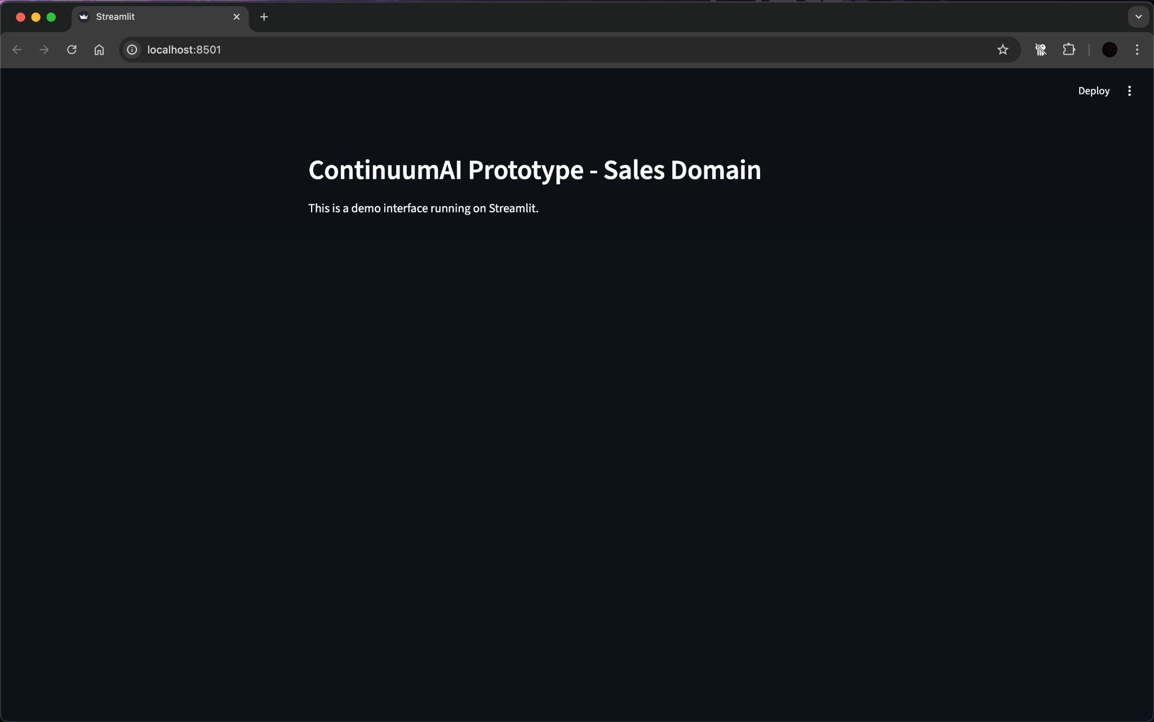

Figure 1: Streamlit interface running locally on http://localhost:8501

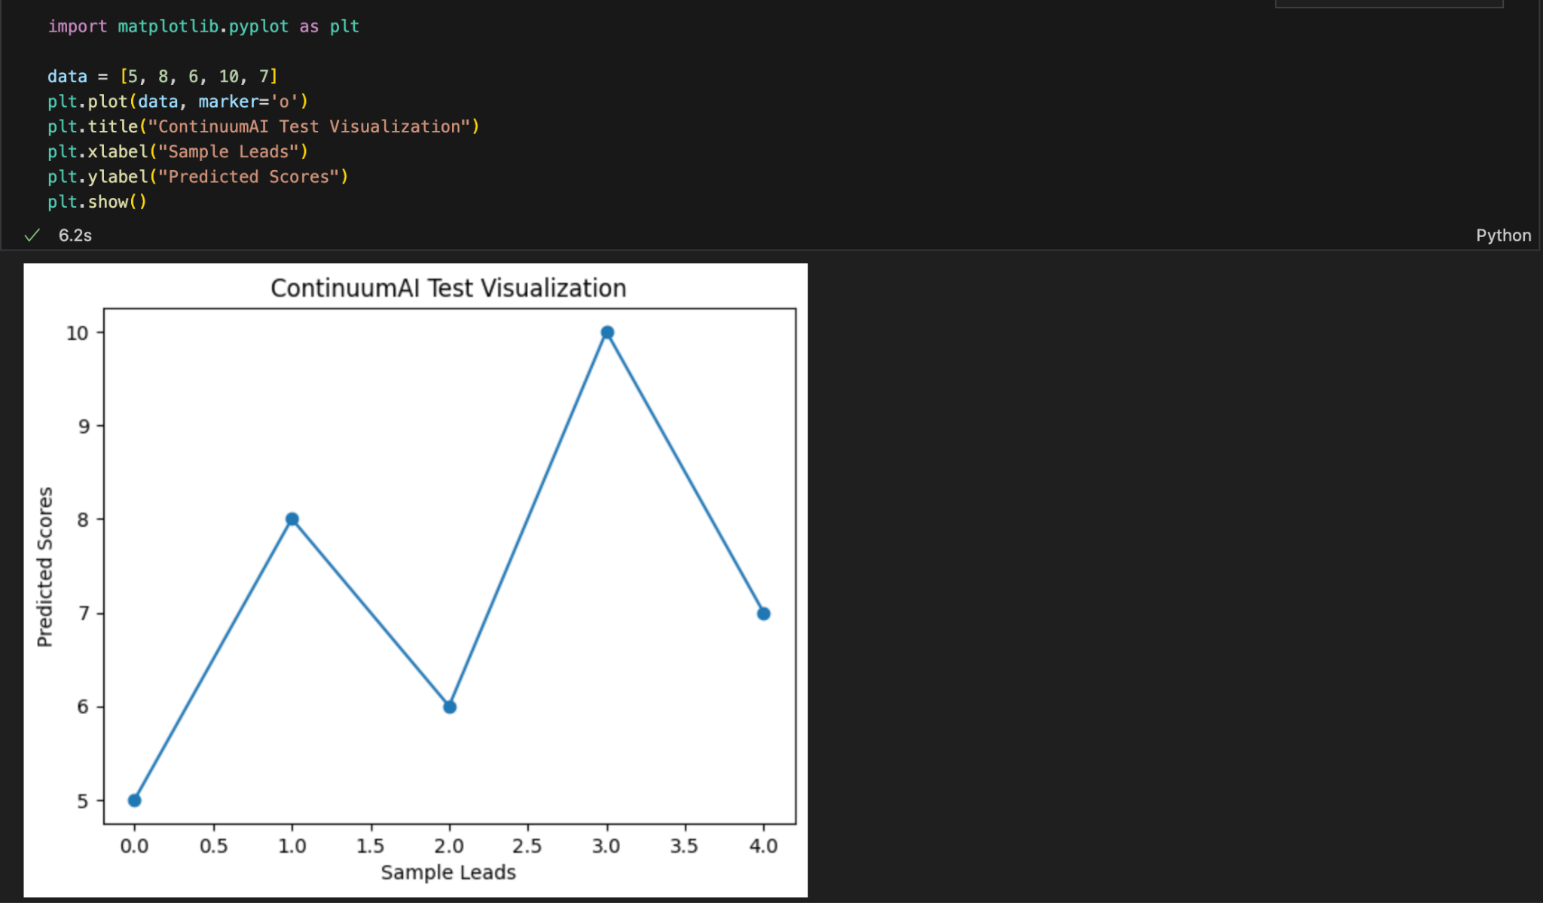

Figure 2: Jupyter Notebook environment running a sample Python visualization on dummy data for ContinuumAI.

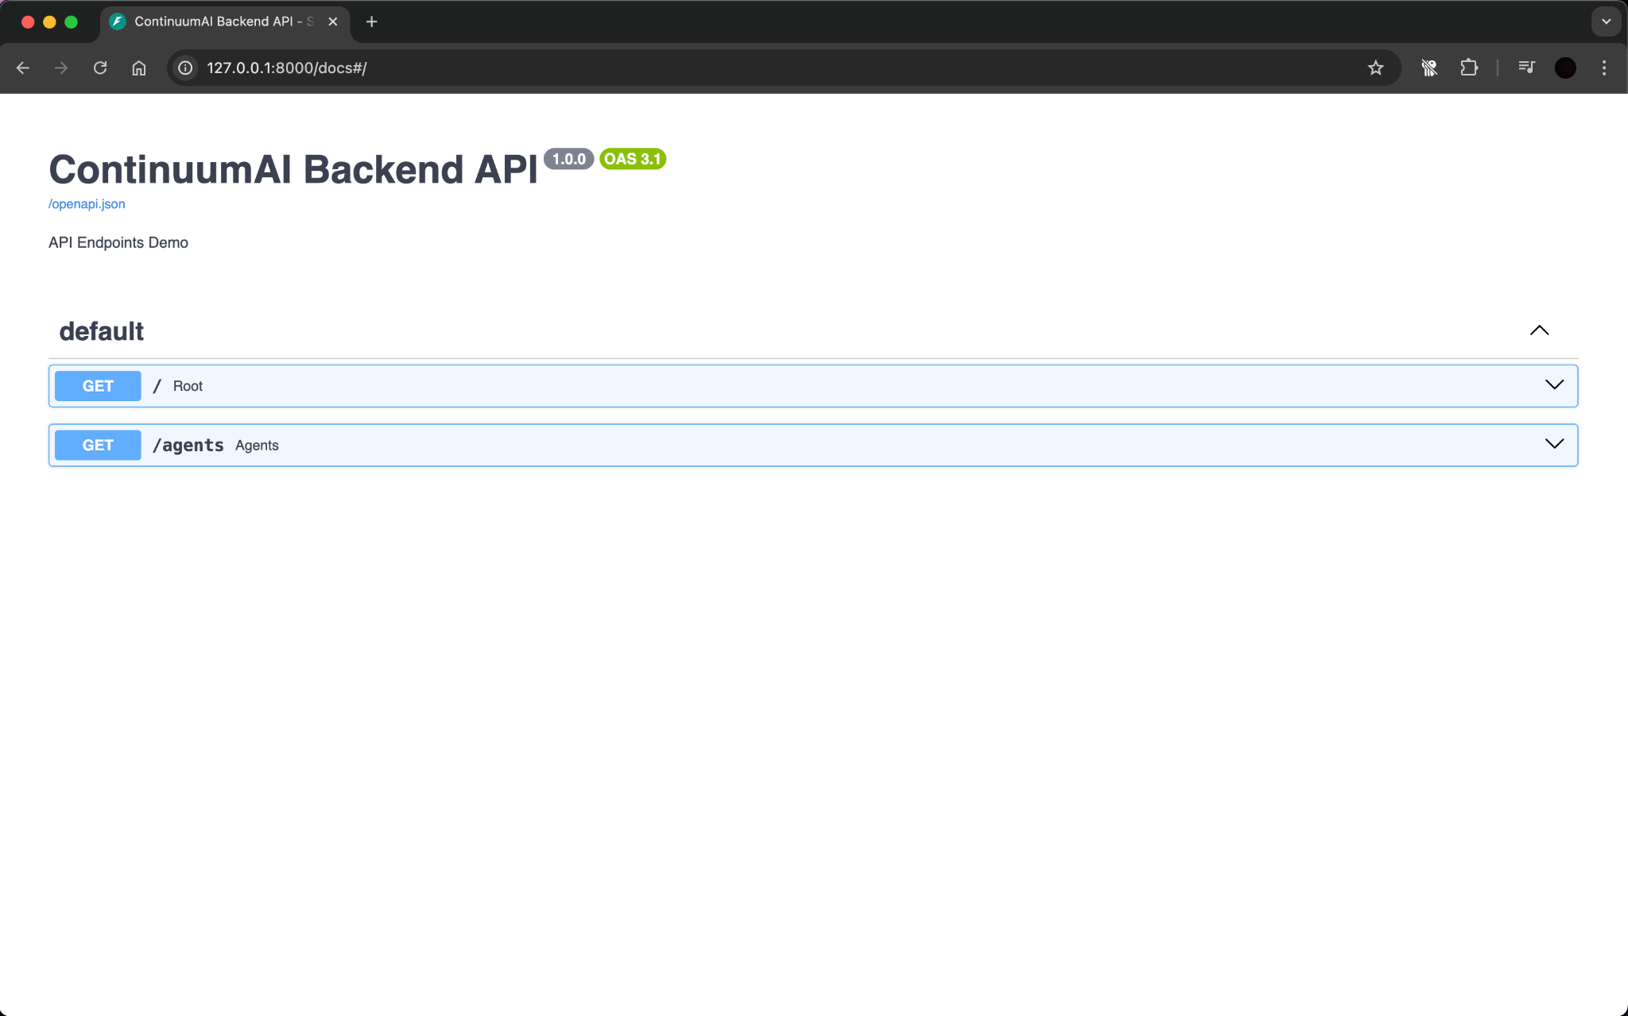
Figure 3: FastAPI Swagger UI displaying available API endpoints (/ and /agents) running locally on http://127.0.0.1:8000/docs

All tools have been verified to run successfully and integrate seamlessly within the local environment. This configuration ensures that both frontend and backend components can be developed, tested, and iterated efficiently, providing a stable foundation for subsequent system implementation and evaluation phases.
.

Deployment Platform
The system will be deployed on Vercel, a free cloud hosting platform designed for modern web applications.
Vercel provides seamless integration with Next.js and React, supports Python FastAPI through serverless functions, and offers automatic continuous deployment from GitHub repositories. It provides a publicly accessible URL, making it ideal for hosting the prototype, sprint builds, and the final system of ContinuumAI.

Use of Generative AI

- Used generative AI to search for relevant tools with minimum run cost.Also to get some knowledge of the hardware compatible for our system.

Who Did What?

Name of the Team Member | Tasks done
Ali Faizan | Sections 1, 4 and 6
Muhammad Bazaf Shakeel | Sections 7, 8 and 9
Umer Raja | Sections 1, 2 and 5
Mustufa | Section 5.1,10
Muhammad Nafees | Section 5, 3

Review checklist

Section Title | Reviewer Name(s)
Section 7,6,8 | Mustufa
Sections 1, 4 | Umer Raja
Section 9 | Muhammad Nafees
Section 5 | Ali Faizan
Section 2 | Muhammad Bazaf Shakeel

13. Revisions

Changes Version 2:
The system architecture was significantly revised to improve modularity, security, and clarity. Key changes include replacing the load balancer and dedicated security middleware with a unified API Gateway that now handles request routing, authentication, and rate limiting. The separate Domain Model Layer was removed, and its responsibilities were merged into the Data Layer to centralize data and business logic. The cache was repositioned as a distributed component managed exclusively by the Agent Orchestration Layer to improve performance and simplify data flow. These changes resulted in a more streamlined four-layer architecture with clearer separation of concerns.
Changes Version 3:
The system architecture was completely redesigned to transition from a conversational AI agent-based system to a data profiling and visualization platform. The previous agent orchestration workflow (Supervisor Agent, specialized agents, LLM APIs) was replaced with a six-layer datamart-centric architecture. Key additions include: a Data Foundation Layer containing the raw SilkRoute schema, an Analytical Storage Layer with pre-joined extensible datamarts (mart_sales, mart_customers, mart_stores), an Intelligence & Metadata Generation Layer housing the Profiling Pipeline with role inference and statistics computation, a Metadata Repository storing validated profile JSONs, and a User Experience Layer comprising Profiling UI, Chart Builder, and Dashboard. This shift prioritizes pre-computed semantic metadata, profile-driven visualization, and domain-oriented datasets over conversational query processing.

Changes Final Version:
In this final iteration, the system architecture has evolved from a linear, six-layer data profiling and visualization tool into a highly decoupled, eight-tier enterprise Decision Intelligence platform. The most significant shift is the deep reintegration of AI; rather than a passive add-on, the AI (VizAgent) now acts as a central orchestrator within a dedicated Domain and Intelligence tier, utilizing robust memory caching and context builders to manage conversational analytics and dynamic chart generation. Furthermore, the previously static metadata repository has been vastly expanded into an active Strategy and Decision Intelligence engine that continuously evaluates key performance indicators (KPIs) against targets using predictive modeling, segmentation, and a dedicated formula engine. To support this proactive stance, the persistence layer has been "tri-furcated" to strictly separate application state (PostgreSQL), analytics data (Gold Marts), and version-controlled business rules (YAML Strategy Configs). Finally, an entirely new operational wing has been introduced to handle comprehensive ops scripts and automated SMTP alerting, officially transforming the application from a passive dashboarding utility into an intelligent, state-aware system capable of driving automated business decisions.

